Ideation phase

Brainstorm and idea prioritization

|  |  |
| --- | --- |
| Date | 30 April 2023 |
| Team ID | NM2023TMID21570 |
| Project Name | Empowering the Future: A Literacy Rate Analysis for a Better Tomorrow. |
| Maximum Marks | 2 Marks |

Empowering the Future: A Literacy Rate Analysis for a Better Tomorrow.

The literacy rate is a key indicator of a country's socio-economic development and human capital. A low literacy rate can lead to lower economic growth, increased poverty, and limited opportunities for social mobility. Therefore, it is important to analyze the literacy rate in different countries to understand the factors that contribute to it and identify strategies to improve it.

The objective of this analysis is to identify the factors that impact the literacy rate in different countries and explore the relationship between these factors and the literacy rate. The analysis will involve collecting data on various socio-economic, demographic, and educational indicators, such as GDP per capita, gender inequality index, school enrollment rates, and adult literacy rates, and analyzing the data using statistical techniques.

The analysis will help to identify the key drivers of literacy rates and provide insights into how policy interventions can improve literacy rates in different countries.

However, accurate and reliable data on literacy rates can be difficult to obtain, and the factors that contribute to low literacy rates can vary widely across regions and countries. To address this problem, a comprehensive analysis of literacy rates is needed, which can provide insights into the factors that contribute to low literacy rates, identify effective strategies for improving literacy rates, and track progress over time.

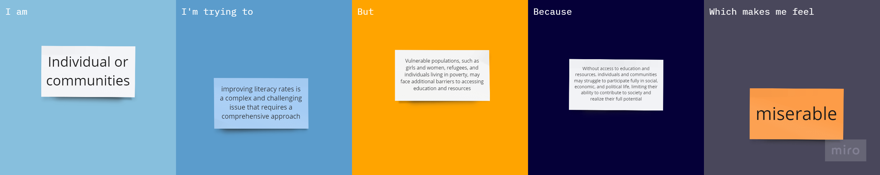

|  |  |  |  |  |  |
| --- | --- | --- | --- | --- | --- |
| **Problem Statement (PS)** | **I am (Customer)** | **I’m trying to** | **But** | **Because** | **Which makes me feel** |
| PS-1 | Individual or communities | improving literacy rates is a complex and challenging issue that requires a comprehensive approach | Vulnerable populations, such as girls and women, refugees, and individuals living in poverty, may face additional barriers to accessing education and resources | Without access to education and resources, individuals and communities may struggle to participate fully in social, economic, and political life, limiting their ability to contribute to society and realize their full potential | miserable |